Topic 11
Dynamic Programming – Graph Algorithms
Bellman-Ford, Floyd-Warshall, Warshall's Algorithm
Dr. Mary Harin Fernandez F

1. Bellman-Ford Algorithm
Given a weighted directed graph and a source vertex, find the shortest distance from the source to all other vertices using the Bellman-Ford algorithm. If the graph contains a negative weight cycle, report it.

Example 1:
Input:
Vertices = 5
Edges = [(0,1,-1),(0,2,4),(1,2,3),(1,3,2),(1,4,2),(3,2,5),(3,1,1),(4,3,-3)]
Source = 0
Output:
Vertex Distance
0 0
1 -1
2 2
3 -2
4 1

Example 2:
Input:
Vertices = 3
Edges = [(0,1,1),(1,2,-1),(2,0,-1)]
Source = 0
Output:
Negative Weight Cycle Detected
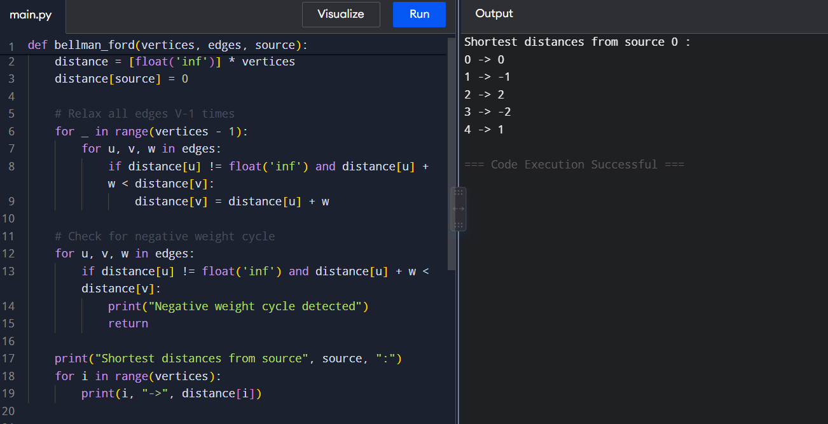

2. Floyd-Warshall Algorithm
Given a weighted graph represented by an adjacency matrix, find the shortest distances between every pair of vertices using the Floyd-Warshall algorithm.

Example 1:
Input:
[
[0,5,INF,10],
[INF,0,3,INF],
[INF,INF,0,1],
[INF,INF,INF,0]
]
Output:
[
[0,5,8,9],
[INF,0,3,4],
[INF,INF,0,1],
[INF,INF,INF,0]
]

Example 2:
Input:
[
[0,2,INF],
[INF,0,4],
[1,INF,0]
]
Output:
[
[0,2,6],
[5,0,4],
[1,3,0]
]
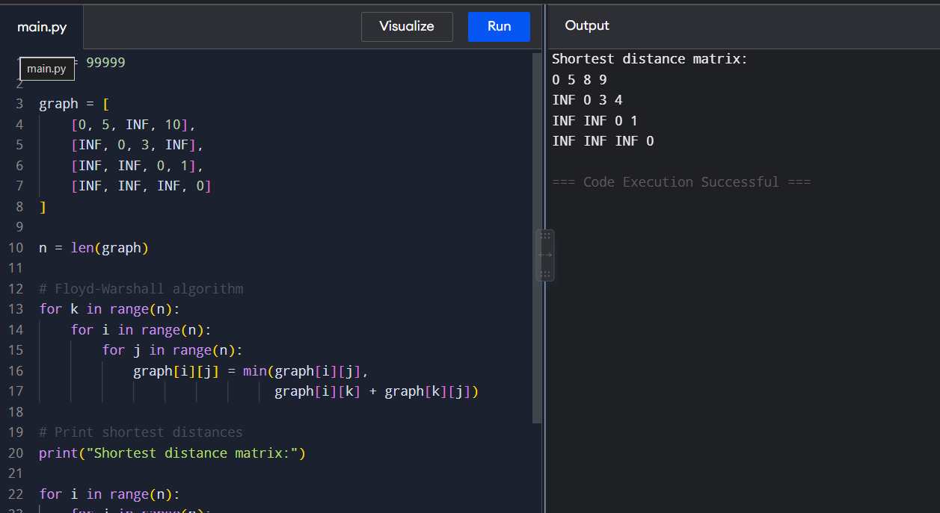

3. Warshall's Algorithm
Given a directed graph represented by an adjacency matrix, determine whether a path exists between every pair of vertices. Compute the transitive closure of the graph using Warshall's algorithm.

Example 1:
Input:
[
[0,1,0,0],
[0,0,1,0],
[0,0,0,1],
[0,0,0,0]
]
Output:
[
[0,1,1,1],
[0,0,1,1],
[0,0,0,1],
[0,0,0,0]
]

Example 2:
Input:
[
[0,1,1],
[0,0,1],
[1,0,0]
]
Output:
[
[1,1,1],
[1,1,1],
[1,1,1]
]
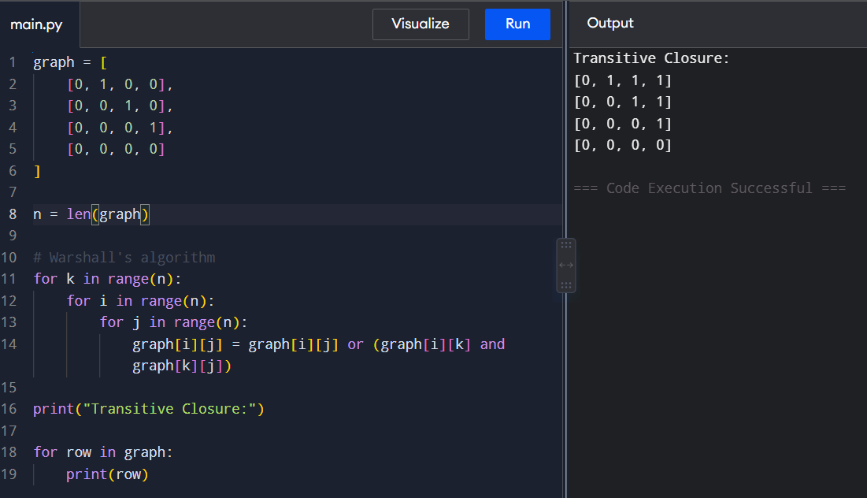

4. Find the City with the Smallest Number of Reachable Cities
Given a weighted graph and a distance threshold, find the city that can reach the smallest number of other cities within the threshold distance. Use Floyd-Warshall algorithm to compute all-pairs shortest paths.

Example 1:
Input:
n=4
edges=[[0,1,3],[1,2,1],[2,3,4],[0,3,7]]
threshold=4
Output:
3
Explanation:
City 3 can reach the fewest cities within the given threshold distance.

Example 2:
Input:
n=5
edges=[[0,1,2],[0,4,8],[1,2,3],[1,4,2],[2,3,1],[3,4,1]]
threshold=2
Compute reachable cities within distance ≤ 2:

Output:
0
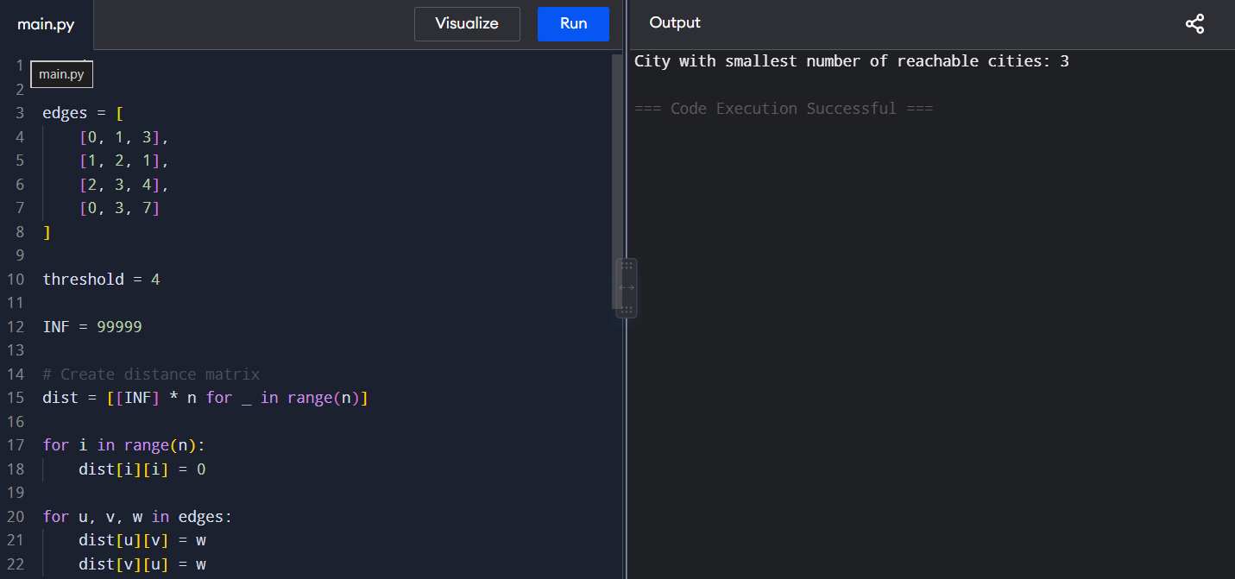

5. Network Delay Time
A signal is sent from a source node to all nodes in a network. Find the minimum time required for all nodes to receive the signal using the Bellman-Ford algorithm. Return -1 if some nodes cannot be reached.

Example 1:
Input:
times=[[2,1,1],[2,3,1],[3,4,1]]
n=4
k=2
Output:
2
Explanation:
The signal reaches all nodes in 2 units of time.

Example 2:
Input:
times=[[1,2,1]]
n=2
k=2
Output:
-1
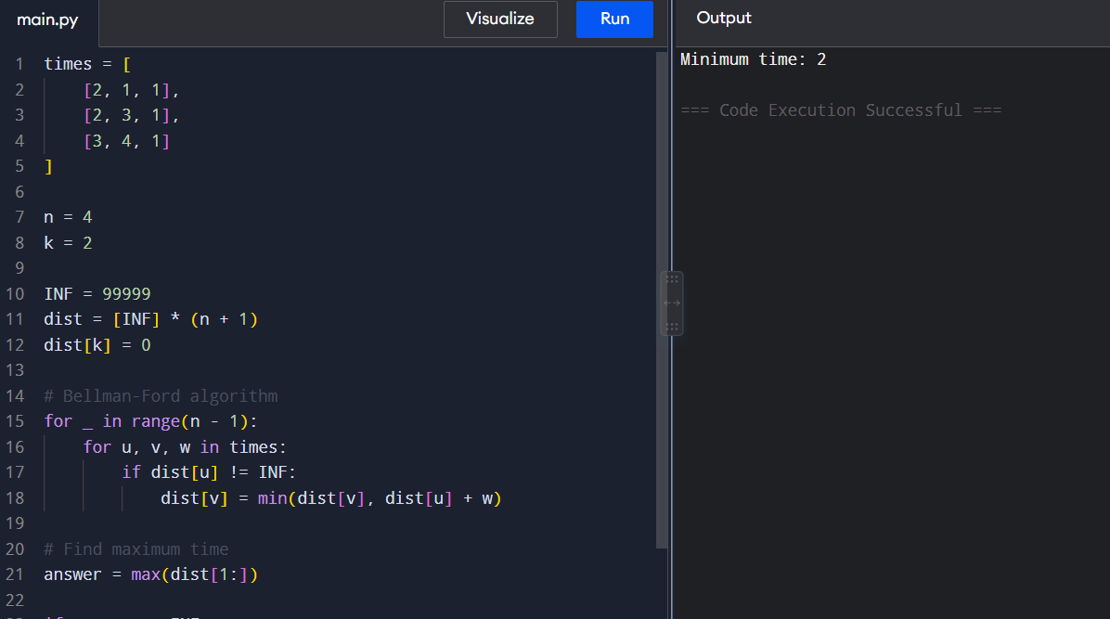

6. Cheapest Flight Within K Stops
Given a list of flights represented as (source, destination, cost), find the minimum cost to travel from the source city to the destination city with at most K stops using the Bellman-Ford algorithm.
Example 1:
Input:
n = 4
flights = [[0,1,100],[1,2,100],[2,3,100],[0,3,500]]
src = 0
dst = 3
K = 1
Output:
500
Explanation:
The route 0→1→2→3 requires 2 stops and is not allowed.

Example 2:
Input:
n = 4
flights = [[0,1,100],[1,2,100],[2,3,100],[0,3,500]]
src = 0
dst = 3
K = 2
Output:
300
Explanation:
The route 0→1→2→3 costs 300 and uses exactly 2 stops.
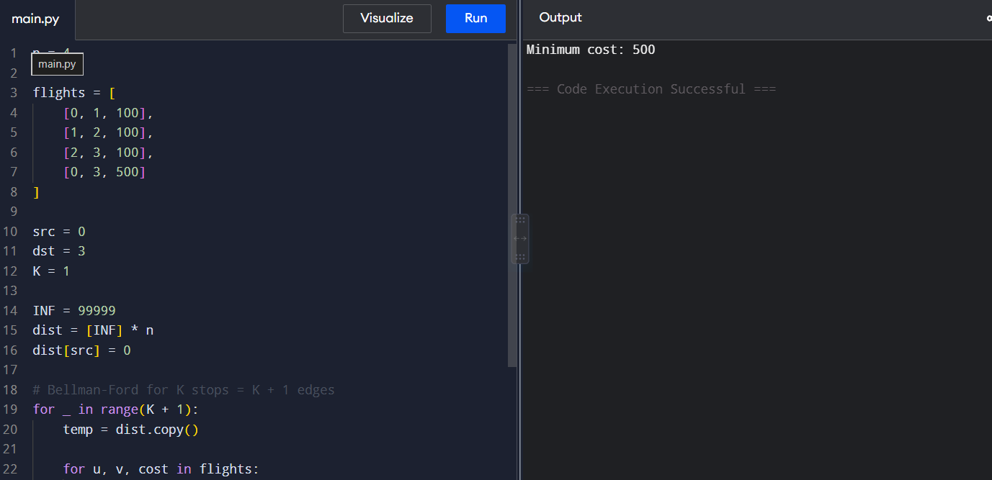

7. Detect Negative Weight Cycle
Given a weighted directed graph, determine whether it contains a negative weight cycle using the Bellman-Ford algorithm.
Example 1:
Input:
Vertices = 4
Edges = [(0,1,1),(1,2,-1),(2,3,-1),(3,0,-1)]
Output:
Negative Weight Cycle Exists
Explanation:
The cycle weight is 1 + (-1) + (-1) + (-1) = -2.

Example 2:
Input:
Vertices = 4
Edges = [(0,1,4),(0,2,5),(1,2,-2),(2,3,3)]
Output:
No Negative Weight Cycle
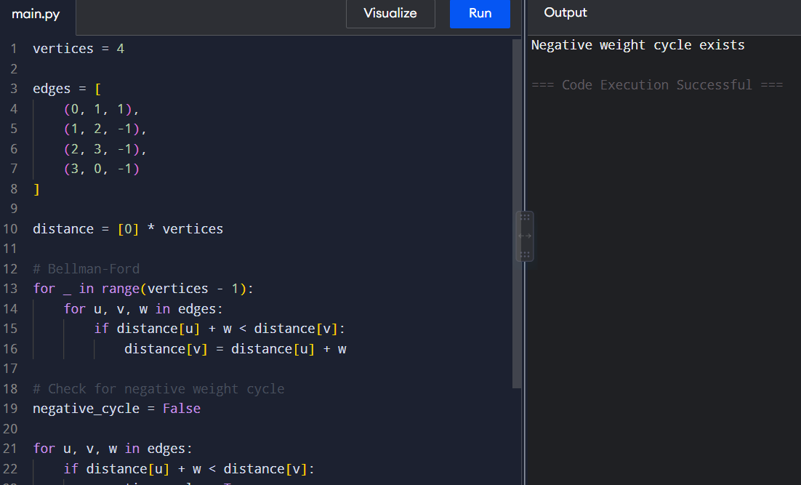

8. Determine Reachability Between Two Vertices
Given a directed graph represented as an adjacency matrix and two vertices u and v, determine whether a path exists from u to v using Warshall's Algorithm.
Example 1:
Input:
Graph =
[
[0,1,0],
[0,0,1],
[0,0,0]
]
u = 0
v = 2
Output:
Path Exists
Explanation:
A path exists from 0 to 2 through vertex 1.

Example 2:
Input:
Graph =
[
[0,1,0],
[0,0,0],
[1,0,0]
]
u = 1
v = 2
Output:
Path Does Not Exist
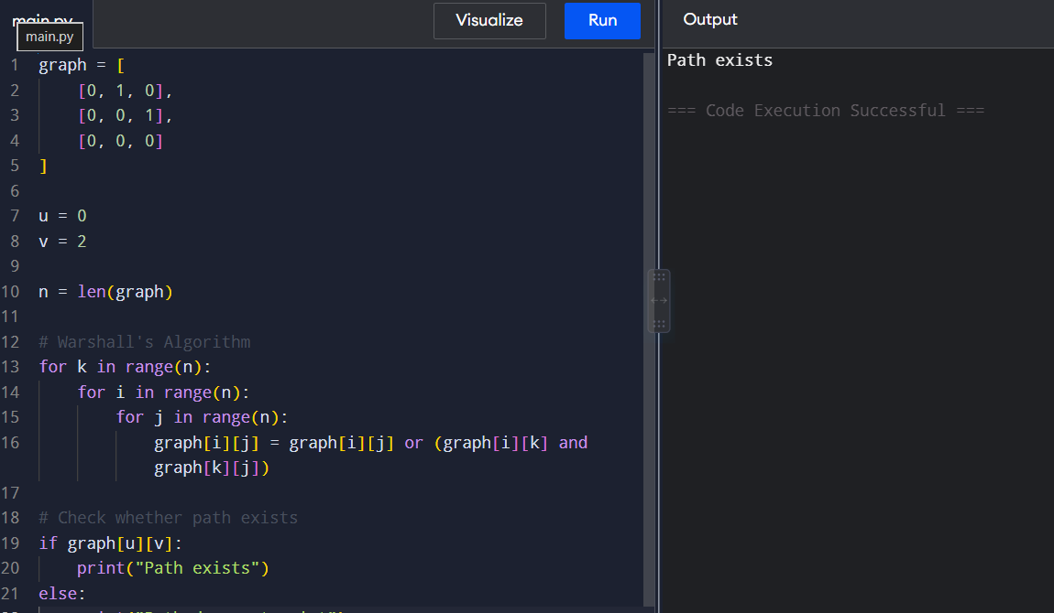

9. Count Reachable Vertices from a Source
Given a directed graph represented by an adjacency matrix, find the number of vertices reachable from a specified source vertex using the transitive closure generated by Warshall's Algorithm. Do not count the source vertex itself.
Example 1:
Input:
Graph =
[
[0,1,0,0],
[0,0,1,0],
[0,0,0,1],
[0,0,0,0]
]
Source = 0
Output:
3
Explanation:
Vertices 1, 2, and 3 are reachable from vertex 0.

Example 2:
Input:
Graph =
[
[0,1,1],
[0,0,1],
[1,0,0]
]
Source = 1
Output:
2
Explanation:
Vertices 0 and 2 are reachable from vertex 1.
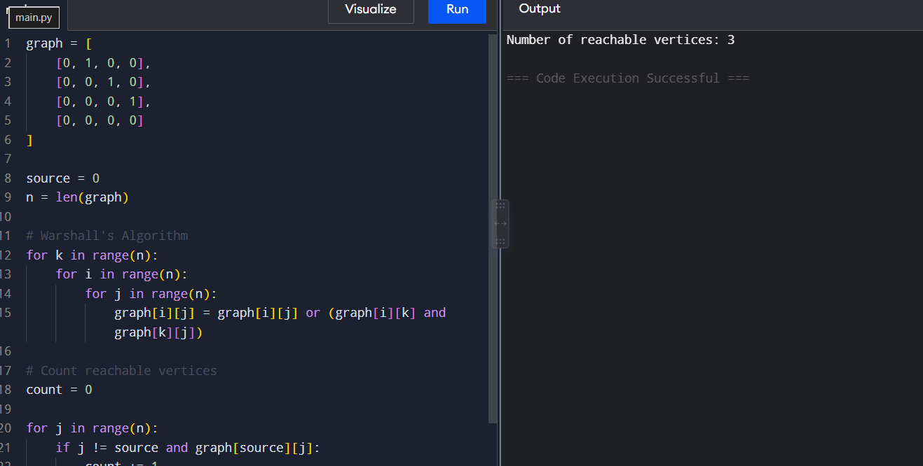

10. Find the Diameter of a Graph
Given a weighted graph represented by an adjacency matrix, find the diameter of the graph using the Floyd-Warshall algorithm. The diameter is the maximum shortest-path distance between any pair of vertices.
Example 1:
Input:
Graph =
[
[0,2,INF],
[2,0,3],
[INF,3,0]
]
Output:
5
Explanation:
The shortest path from vertex 0 to vertex 2 is 0→1→2 with cost 5.

Example 2:
Input:
Graph =
[
[0,1,4],
[1,0,2],
[4,2,0]
]
Output:
3
Explanation:
The shortest path from vertex 0 to vertex 2 is 0→1→2 with cost 3, which is the graph diameter.
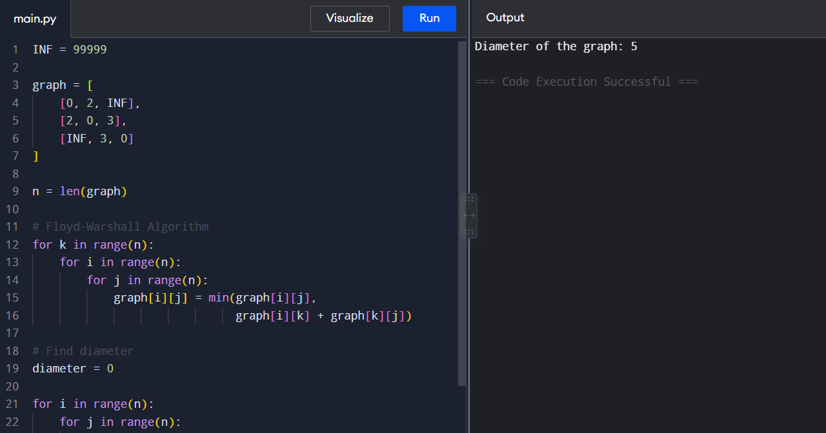

11. Find the Shortest Distance Between Two Vertices
Given a weighted graph represented by an adjacency matrix and two vertices u and v, find the shortest distance between them using the Floyd-Warshall algorithm.
Example 1:
Input:
Graph =
[
[0,3,INF,7],
[8,0,2,INF],
[5,INF,0,1],
[2,INF,INF,0]
]
u = 0
v = 3
Output:
6
Explanation:
Shortest path: 0 → 1 → 2 → 3
Distance = 3 + 2 + 1 = 6
Example 2:
Input:
Graph =
[
[0,4,INF],
[INF,0,6],
[2,INF,0]
]
u = 2
v = 1

Output:
6

Explanation:
Shortest path: 2 → 0 → 1
Distance = 2 + 4 = 6
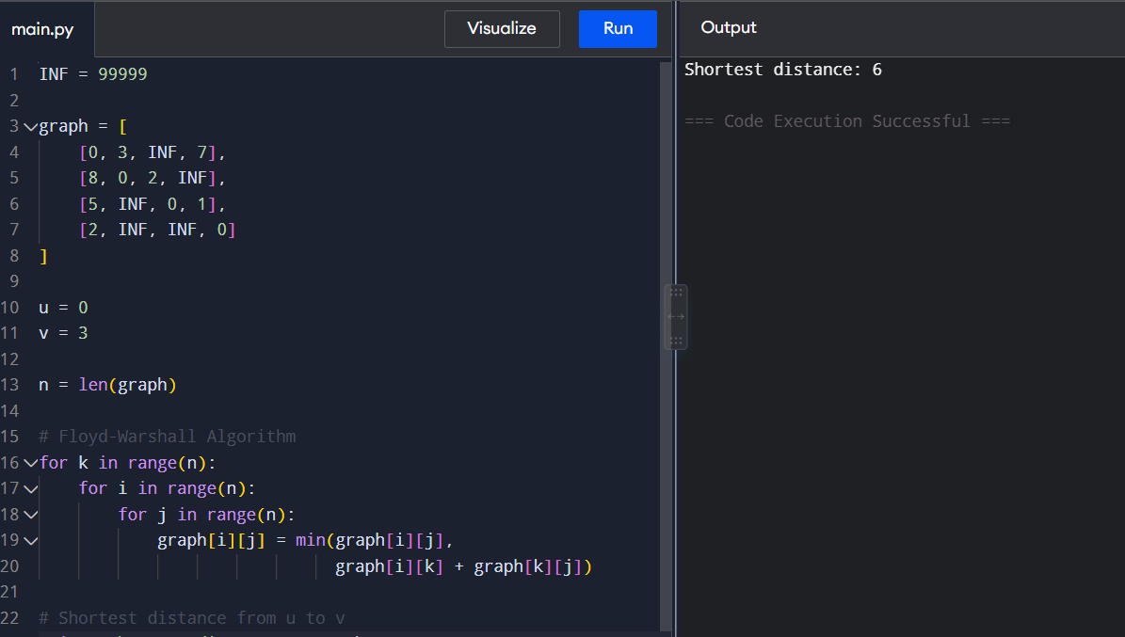

12. Find a Vertex Reachable from Every Other Vertex
Given a directed graph represented by an adjacency matrix, find a vertex that is reachable from every other vertex using Warshall's Algorithm. If multiple vertices satisfy the condition, return the smallest indexed vertex.
Example 1:
Input:
Graph =
[
[0,1,1],
[0,0,1],
[0,0,0]
]
Output:
2
Explanation:
Vertices 0 and 1 can reach vertex 2.

Example 2:
Input:
Graph =
[
[0,1,0],
[0,0,1],
[1,0,0]
]
Output:
0
Explanation:
All vertices are reachable from every other vertex.
Return the smallest indexed vertex.
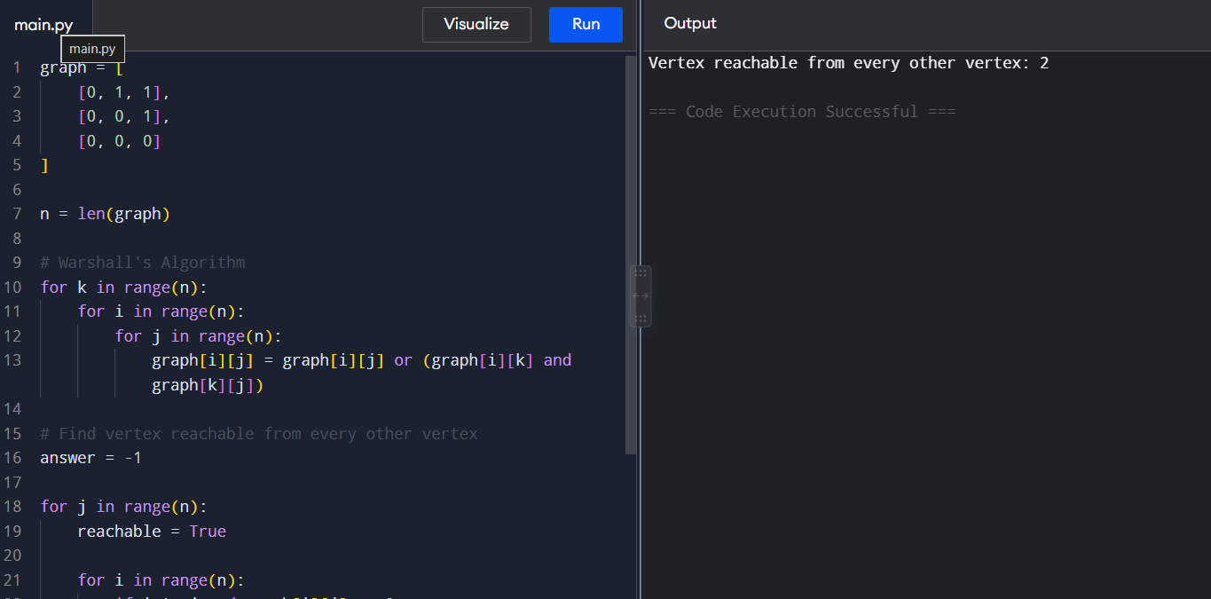

13. Find the Vertex with Maximum Reachability
Given a directed graph represented by an adjacency matrix, find the vertex that can reach the maximum number of other vertices using Warshall's Algorithm. If there is a tie, return the smallest indexed vertex.
Example 1:
Input:
Graph =
[
[0,1,1,0],
[0,0,1,0],
[0,0,0,1],
[0,0,0,0]
]
Output:
0
Explanation:
Vertex 0 can reach vertices 1, 2 and 3.
Example 2:
Input:
Graph =
[
[0,1,0],
[0,0,1],
[1,0,0]
]
Output:
0
Explanation:
All vertices can reach two other vertices.
Return the smallest indexed vertex.
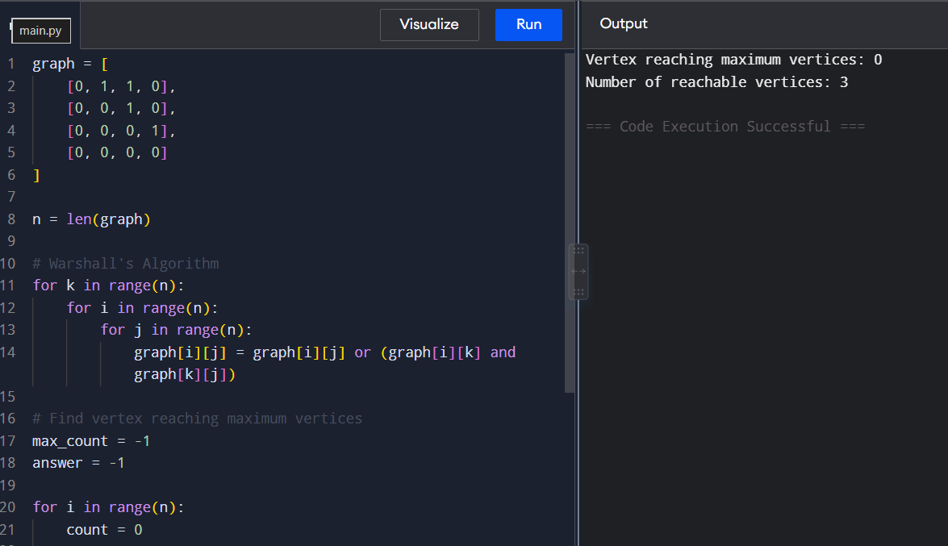

14. Find the Diameter of a Weighted Graph
Given a weighted graph represented by an adjacency matrix, find the diameter of the graph using the Floyd-Warshall algorithm. The diameter is the maximum shortest-path distance between any pair of vertices.
Example 1:
Input:
Graph =
[
[0,2,INF],
[2,0,4],
[INF,4,0]
]
Output:
6
Explanation:
Shortest path from 0 to 2 is:
0 → 1 → 2 = 6
Diameter = 6

Example 2:
Input:
Graph =
[
[0,1,5],
[1,0,2],
[5,2,0]
]
Output:
3
Explanation:
Shortest path from 0 to 2 is:
0 → 1 → 2 = 3
Diameter = 3
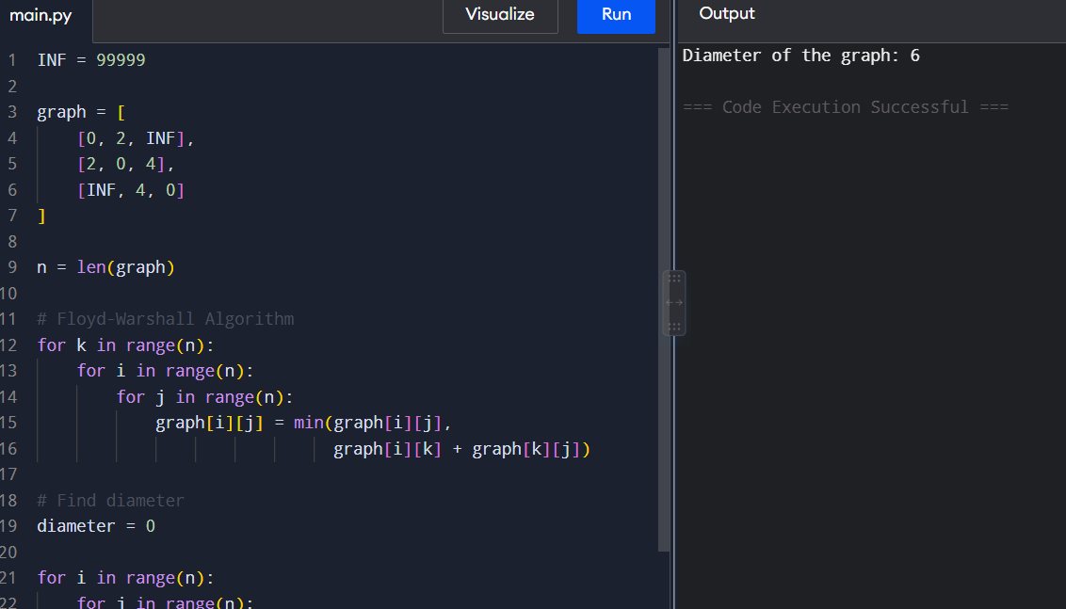
15. Check Whether a Graph is Strongly Connected
Given a directed graph represented by an adjacency matrix, determine whether every vertex is reachable from every other vertex using Warshall's Algorithm.
Example 1:
Input:
Graph =
[
[0,1,0],
[0,0,1],
[1,0,0]
]
Output:
Strongly Connected
Explanation:
Every vertex can reach every other vertex.

Example 2:
Input:
Graph =
[
[0,1,0],
[0,0,1],
[0,0,0]
]
Output:
Not Strongly Connected
Explanation:
Vertex 2 cannot reach vertices 0 and 1.
